# The structure of the server

The structure of the server side is shown in Figure 1-1. There are three major components in server: models, servlets and database driver. The package model contains the prototype of tables in database. The database driver (DBFacade) is a wrapper package for database operations (CRUD). The package servlets is utilized for the connection between client and server.

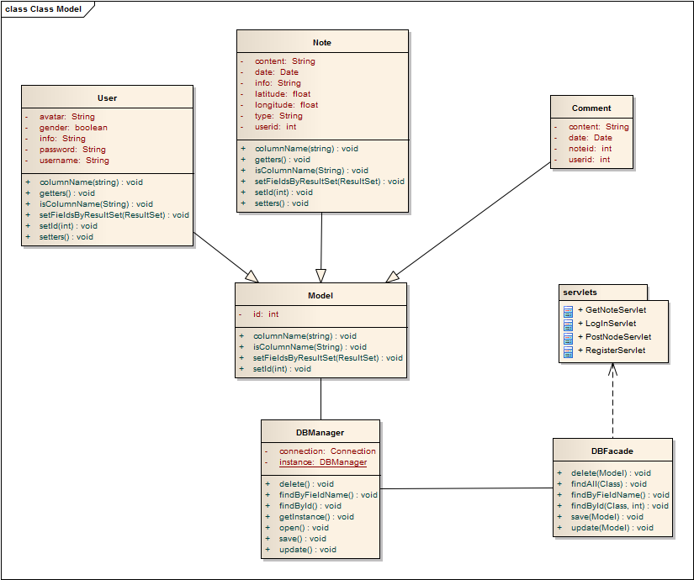

Figure 1-1 The class diagram of the server side

# Feature completed

We have completed the models part and database part as well as the majority work in servlets parts. Now the server can react to all the requests except for the profile upload/download request.

For the detail information about the protocols, please refer to the protocol document.

# Feature unfinished

As mentioned above, the server cannot response to profile upload/download request. We will finish this part in the following several days.